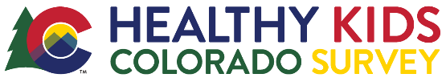
Teacher Reminder Email Template

for Survey Coordinators

Be sure to customize this template, especially highlighted text, and feel free to adjust any other wording. This template is to help save you time & provide the most important information to communicate to your teachers! Thank you for coordinating this effort.

Hello <Name>,
Our 2021 Healthy Kids Colorado Survey (HKCS) administration day is just around the corner! Our school will survey on <date>. Now is a good time to check in on any parent opt-outs you may have received to track which students will not be taking the survey. You can collect opt-outs up until the survey day.
Here are your Teacher Instructions again and our school’s survey link: <insert survey link>.
This is the survey link to share with students electronically on the day of our survey – please plan for a way to distribute this to students now, such as emailing them or posting on your teacher/student platform. Please do not rely on students manually typing in this link, but provide them with a link to click on to start their survey.
Additionally, make sure there are enough devices for each student to take the survey. Now is a good time to remind students that the survey day is coming up and that your class plans to participate in this important effort. Let me know if I can help!
If you have any questions, please reach out ASAP. Thank you again for helping me make this happen for our school and students!

<insert signature>

