The Whole School, Whole Community, Whole Child (WSCC) Model provides a framework for schools to use when creating a healthy environment that supports student success. The model is centered on students and calls for collaboration across school, community, and health sectors to meet the needs and support the potential of each student.

Directions: Write activities, actions, and/or person(s) or organization(s) to address your school’s health and wellness priority, specifically for your SMART objective.
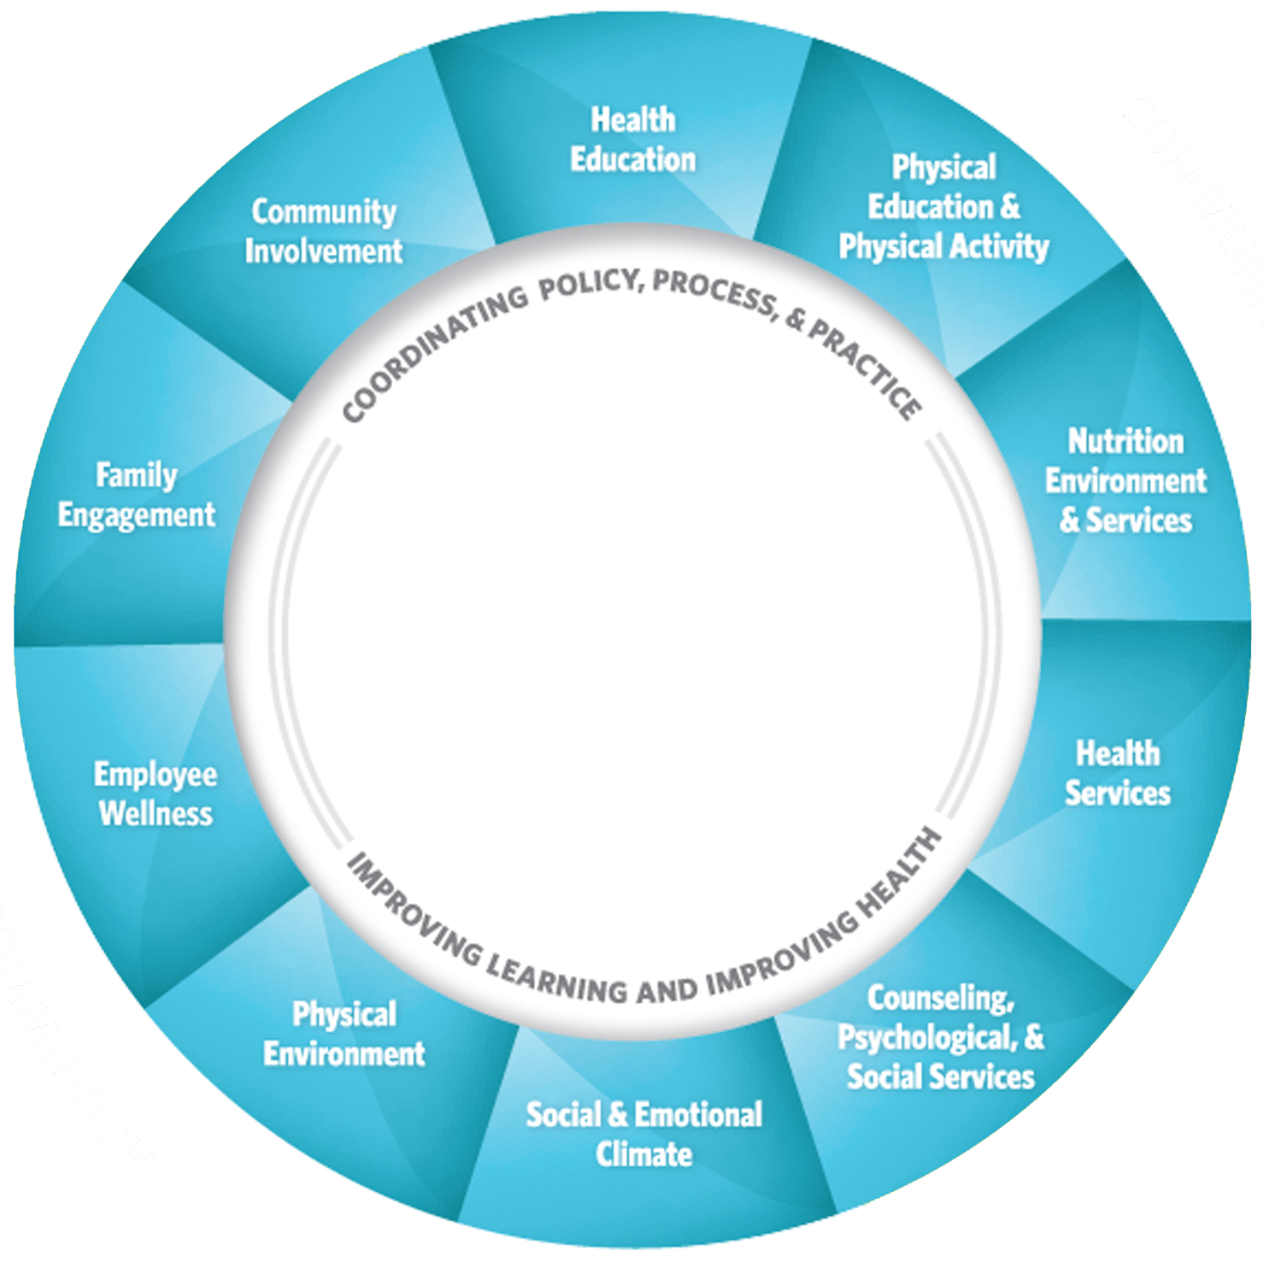
Students:
Nutrition:
Community Involvement:
Family Engagement:
Employee Wellness:
Physical Environment:
Social/Emotional:
Counseling/Psych/Social:
Health Services:
PE / PA:
Health Education:

