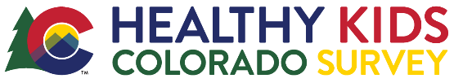
Teacher Reminder Email Template

for Survey Coordinators – YRBS Class Rooms

Be sure to customize this template, especially highlighted text, and feel free to adjust any other wording. This template is to help save you time & provide the most important information to communicate to your teachers! Thank you for coordinating this effort.

Hello <Name>,
Our 2021 Healthy Kids Colorado Survey (HKCS) administration day is just around the corner! Our school will survey on <date>. Now is a good time to check in on any parent opt-outs you may have received to track which students will not be taking the survey. You can collect opt-outs up until the survey day.
Here are your Teacher Instructions again. I will make sure you have packets of surveys for you to distribute.
Now is a good time to remind students that the survey day is coming up and that your class plans to participate in this important effort. Let me know if I can help!
If you have any questions, please reach out ASAP. Thank you again for helping me make this happen for our school and students!

<insert signature>

