Tracking Parental Consent
Instructions

Using a Google Form is a simple and free way for you to track which parents are choosing to opt their student out of the 2021 HKCS. Of course, you may choose any method to track student opt-outs that works best for you.
Follow the brief instructions below on how to use our Google Form for tracking parent consent.

Step 1. Click on this link to open the template Google Form

Step 2. Click on “Make a Copy”
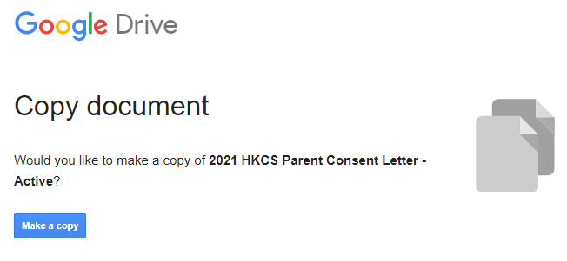

Step 3. In the top right corner, hit “Send” to send the form electronically to all parents of your classroom(s) taking the survey
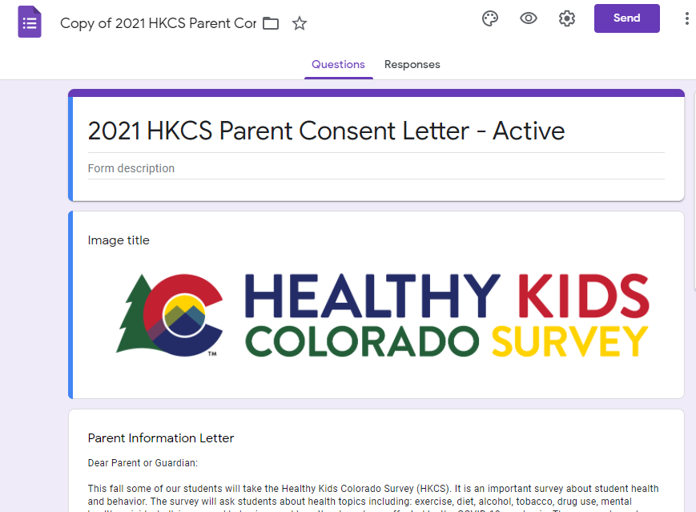

Step 4. Choose one of two options for sending the form to parents

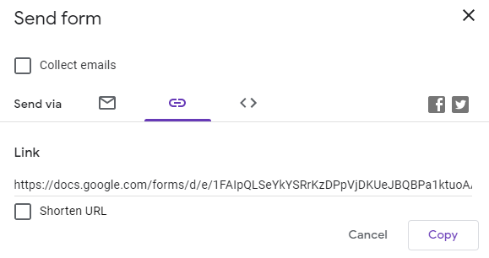
#1. Enter all parents’ emails and send the form through Google

#2. Copy the link of your form by clicking “Copy” and paste this into an email to parents

Step 5. Track responses from parents by opening your Google Form and clicking on the “Responses” tab

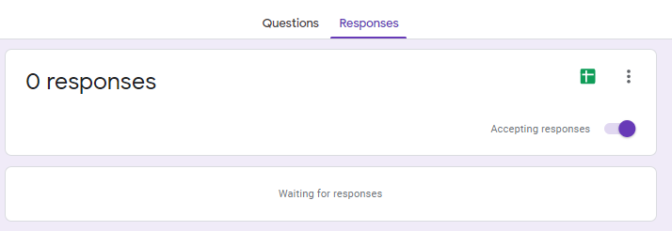

Important Notes:
- Parents need to return this form regardless of whether they want their student to participate or not.

- If a parent has not submitted this form, make sure their student does not participate in the survey. They may sit quietly and work on other schoolwork while other students complete the survey.

- Tracking results do not need to be shared with the CSPH Survey team, and are just for you to know which students will or will not participate in the survey.

If you need additional support, email us at CSPHSurveyTeam@cuanschutz.edu.

